UNIT-2

* Introduction
* Organizational Support for Design
* The Design Process
* Design Frameworks
* Design Methods
* Design Tools, Practices, and Patterns
* Social Impact Analysis
* Legal Issues

Direct Manipulation

* Introduction
* What Is Direct Manipulation?
* Some Examples of Direct Manipulation
* 2-D and 3-D Interfaces
* Teleoperation and Presence
* Augmented and Virtual Reality

**Introduction**

Designing a user interface (UI) is a crucial aspect of creating a positive user experience for any digital product, whether it's a website, mobile app, or software application. Here are some essential principles and guidelines to consider when designing a user interface:

* User-Centered Design
* Simplicity and Clarity
* Consistency
* Hierarchy and Visual Organization
* Navigation
* Feedback and Responsiveness
* Accessibility
* Visual Appeal
* Mobile Responsiveness
* Error Handling
* User Testing and Iteration
* Loading Times
* Micro interactions
* Prioritize Content
* **User-Centered Design:** The most important aspect of UI design is to keep the user at the center. Conduct user research, interviews, and usability testing to gain insights into user behavior and expectations.
* **Simplicity and Clarity:** Keep the interface simple, clean, and easy to understand. Avoid clutter and unnecessary elements. Use concise and clear language in labels, instructions, and error messages.
* **Consistency:** Maintain consistency throughout the interface to create a sense of familiarity for users. Consistent visual elements, layout, and interactions help users understand how to navigate and use the product.
* **Hierarchy and Visual Organization:** Use visual cues such as size, color, and typography to establish a clear hierarchy of information. Important elements should stand out, and related items should be grouped together logically.
* **Navigation:** Design an intuitive navigation system that allows users to move seamlessly through the product. Use standard navigation patterns when possible, such as a top menu or a hamburger menu for mobile devices.
* **Feedback and Responsiveness:** Provide instant and meaningful feedback to user actions. For example, buttons should change appearance when clicked, and loading indicators should be displayed during lengthy processes.
* **Accessibility:** Ensure that your UI is accessible to all users, including those with disabilities. Use proper color contrast, provide alternative text for images, and make sure the interface is navigable with a keyboard.
* **Visual Appeal:** While simplicity is essential, aesthetics matter too. Use a visually appealing color scheme, appropriate typography, and relevant imagery to create an engaging interface.
* **Mobile Responsiveness:** If designing for multiple devices, ensure the interface adapts well to different screen sizes and resolutions. Optimize touch controls for mobile devices.
* **Error Handling:** Design error messages that are clear, helpful, and offer solutions to resolve the issue. Avoid technical jargon that might confuse users.
* **User Testing and Iteration:** Test your interface with real users and gather feedback. Use this feedback to make iterative improvements to the design.
* **Loading Times:** Optimize the UI for fast loading times, as slow interfaces can lead to user frustration.
* **Micro interactions:** Add subtle animations and micro interactions to improve user engagement and delight. For example, a button changing color on hover or a subtle transition when opening a menu.
* **Prioritize Content:** Ensure that the most important content and features are easily accessible and prominently displayed.

Remember that UI design is an iterative process, and it's essential to continuously gather feedback and make improvements to create a user-friendly and visually appealing interface.

**Organizational Support for Design**

Most companies may not yet have chief usability officers (CUOs) or vice presidents for usability, but some companies are beginning to employ chief design officers (CDOs), which may help to promote usability and design thinking at every level. A case in point is Apple Inc., which was one of the first companies with a CDO and which accordingly has been praised for its innovative, well-designed, and usable products.

Organizational support for design in digital interaction is crucial for creating successful products and services. When an organization prioritizes and fosters a design-centric culture, it leads to better user experiences, increased customer satisfaction, and ultimately, higher business success.

Here are some key elements of organizational support for design:

* **Design Leadership and Advocacy**: Having design leaders at the executive level who understand the value of design and advocate for its integration across the organization is essential. These leaders can champion design initiatives, allocate resources, and ensure that design is considered in strategic decision-making.
* **Design Team and Expertise**: Employing skilled and diverse design professionals who can bring a human-centered approach to problem-solving is crucial. This includes designers with expertise in various domains such as graphic design, user experience (UX) design, industrial design, etc.
* **Cross-Functional Collaboration**: Encouraging collaboration between design teams and other departments (e.g., engineering, marketing, product management) helps break down silos and ensures that design is integrated throughout the entire product development or service delivery process.
* **User-Centric Approach**: Organizations should promote a user-centric mindset where understanding the needs and pain points of customers or end-users is prioritized. User research and feedback should be regularly incorporated into the design process.
* **Design Thinking Workshops and Training**: Providing employees with opportunities to learn about design thinking methodologies can foster a culture of innovation and problem-solving. Training programs can help non-designers understand the value of design and how it complements their work.
* **Design Guidelines and Standards**: Developing and adhering to design guidelines and standards ensures consistency and a cohesive brand identity across products and services.
* **Investment in Design Tools and Technology**: Equipping design teams with the necessary tools and software can boost productivity and enable them to create high-quality designs efficiently.
* **Recognition and Rewards**: Recognizing and rewarding design contributions and successes can motivate teams and individuals to continue striving for excellence in their work.
* **Prototyping and Iteration**: Supporting iterative design processes, where prototypes are created, tested, and refined based on user feedback, can lead to better end products and services.
* **Top-Down Support**: Organizational support for design should come from the top management, ensuring that design initiatives are given the attention and resources they need to succeed.

**The Design Process**

Design is inherently creative and unpredictable, regardless of discipline. In the context of interactive systems, successful designers blend a thorough knowledge of technical feasibility with an uncanny aesthetic sense of what attracts and satisfies users. One way to define design is by its operational characteristics:

* Design is a process: it is not a state, and it cannot be adequately represented statically.
* The design process is nonhierarchical: it is neither strictly bottom-up nor strictly top-down.
* The process is radically transformational: it involves the development of partial and interim solutions that may ultimately play no role in the final design.
* Design intrinsically involves the discovery of new goals

These characterizations of design convey the dynamic nature of the process. An iterative design process based on this operational definition would consist of four distinct phases.

* requirements analysis (Phase 1),
* preliminary and detailed design (Phase 2),
* build and implementation (Phase 3),
* evaluation (Phase 4)

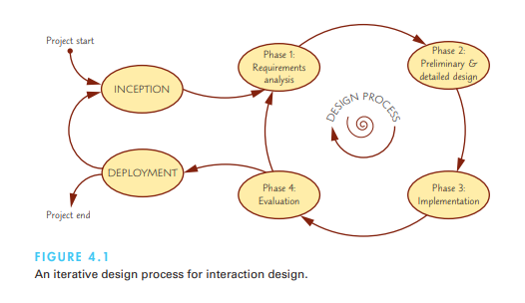

**Requirements analysis**

* This phase collects all of the necessary requirements for an interactive system or device and yields a requirements specification or document as its outcome. In general, soliciting, capturing, and specifying user requirements are major keys to success in any development activity (Selby, 2007). Methods to elicit and reach agreement upon interaction requirements differ across organizations and industries, but the end result is the same: a clear specification of the user community and the tasks the users perform
* Thus, even requirements documents written specifically for user experience and interaction design aspects are often specified in terms of three components :
* **Functional requirements:** define specific behavior that the system should support (often captured in so-called use cases, see below);
* **Non-functional requirements:** specify overall criteria governing the operation of the interactive system without being tied to a specific action or behavior (hardware, software, system performance, reliability, etc.); and
* **User experience requirements:** explicitly specify non-functional requirements for the user interaction and user interface of the interactive system (navigation, input, colors, etc.).

**Preliminary and detailed design**

The core of the design process is realizing the requirements from the previous phase. The design phase in turn consists of two stages: a preliminary stage, where the high-level design or architecture of the interactive system is derived, and a detailed stage, where the specifics of each interaction are planned out. The outcome from the design phase is a detailed design document.

The preliminary design is also known as architectural design, and in engineering settings this stage often entails deriving the architecture of the system. For user experience and interaction design, preliminary design consists of mapping out the high-level concepts such as the user, controls, interface displays, navigation mechanisms, and overall workflow.

Preliminary design can also be called conceptual design, particularly in software engineering, because it is sometimes useful to organize the high-level concepts into a conceptual map with their relations. Overall, this activity is about developing the mental model that users should have about the interactive system when using it.

Examples of suitable design methods include sketching, paper mockups, and high-fidelity prototypes. Furthermore, all methods can be informed through the use of tools, patterns, and best practices. For example, guidelines documents give direction on specific design choices, such as menu design, display layout, and navigation techniques. Patterns suggest effective ways to design an interface, such as single-page applications for websites or multi-document interfaces for desktop tools. Dedicated wireframing tools allow for rapidly creating mockups of a design

**Build and implementation**

* The implementation phase is where all of the careful (or not very careful at all, depending on your design approach; see the agile development framework) planning gets turned into actual, running code. The outcome from this phase is a working system, albeit not necessarily the final one. some suitable software development platforms for interactive applications based on your computing platform:
* **Mobile**: Building mobile apps typically requires using the SDK (software development kit) and development environment provided by the manufacturer of the operating system: the Android SDK in Java, the Apple iOS SDK in Objective-C, and the Windows Phone/Mobile SDKs. Most of these SDKs require registering as a developer to have access to the app exchange for making your app available to general users. Since mobile app development typically is cross-platform—the development is actually conducted on a personal computer—all of these SDKs include emulators for testing the app on a virtual phone residing on the personal computer itself.
* **Web**: The browser has become a ubiquitous information access platform, and modern web technologies are both pervasive and full-featured to the point that they can emulate or replace traditional computer software. Web applications and services typically consist of both client and server software: Client-side software runs in the user’s browser and is accordingly built in JavaScript—the programming language of the browser—whereas server-side software runs on the web server or connected hosts and is often implemented in languages such as PHP, Ruby, Java, or even JavaScript (using Node.js).
* **Personal Computers:** Developing dedicated applications for a personal computer typically requires using the native SDKs for the specific operating system. Development environments such as Microsoft’s Visual Basic/C++ are easy to get started with yet have an excellent set of features

**Evaluation phase**

* In the final phase of the design cycle, developers test and validate the system implementation to ensure that it conforms to the requirements and design set out earlier in the process. The outcome of the validation process is a validation report specifying test performance Depending on this outcome, the design team can decide to proceed with production and deployment of the system or to continue another cycle through the design process. Validation is a vital part of the design process.
* Theatrical producers know that extensive rehearsals and previews for critics are necessary to ensure a successful opening night. Early rehearsals may involve only the key performers wearing street clothes, but as opening night approaches, dress rehearsals with the full cast, props, and lighting are required. Aircraft designers carry out wind tunnel tests, build plywood mockups of the cabin layout, construct complete simulations of the cockpit, and thoroughly flight-test the first prototype. Similarly, website designers know that they must carry out many small and some large pilot tests of components before release to customers.

**Design Frameworks**

While the design process discussed above generally should remain the same for all your projects, the approach to performing it may vary. The concept of design frameworks captures this idea: the specific flavor and approach the design takes to conducting the design process. More specifically, interaction design practice over the past few decades has unearthed several unique approaches to conducting the design process. This section reviews the concepts of user-centered design (UCD), participatory design (PD), and the nascent idea of agile interaction design.

**User-centered design**

* Many software development projects fail to achieve their goals; some estimates of the failure rate put it as high as 50% (Jones, 2005). Much of this problem can be traced to poor communication between developers and their business clients or between developers and their users. The result is often systems and interfaces that force the users to adapt and change their behavior to fit the interface rather than an interface that is customized to the needs of the users. User-centered design (UCD) is a counterpoint to this fallacy and prescribes a design process that primarily takes the needs, wants, and limitations of the actual end users into account during each phase of the design process

**Participatory design**

* Going beyond user-centered design, participatory design (PD) (also known as cooperative design in Scandinavia) is the direct involvement of people in the collaborative design of the things and technologies they use. The arguments in favor suggest that more user involvement brings more accurate information about tasks and an opportunity for users to influence design decisions. The sense of participation that builds users’ ego investment in successful implementation may be the biggest influence on increased user acceptance of the final system.
* Participatory design experiences are usually positive, however, and advocates can point to many important contributions that would have been missed without user participation.

**Agile interaction design**

* Traditional design processes can be described as heavyweight in that they require significant investments in time, manpower, and resources to be successful. In particular, such processes are often not sufficiently reactive to today’s fast-moving markets and dynamic user audiences. Originally hailing from software engineering, agile development is a family of development methods for self-organizing, dynamic teams that facilitate flexible, adaptive, and rapid .

**Design methods:**

* Design methods are the practical building blocks that form the actual day-today activities in the design process. There are dozens of design methods in the literature, but designers may want to focus on the most common ones.
* For example, participatory and user-centered design tends to incorporate a lot of ethnographic observation, whereas rapid and agile development employs sketching to a high degree. However, the design frameworks also provide a flavor for the overall process and each of the design methods: An agile approach to sketching will focus on collecting quick ideas from the design team, whereas a user-centered or participatory approach will let the intended users themselves be part of the sketching process.

**Ideation and creativity**

* One way to think about design is as an incremental fixation of the solution space, where the range of possible solutions is gradually whittled down until only a single solution exists. This is the final product or service that then goes on to ship and be deployed. Gradually reducing the solution space in this manner is called convergence or convergent thinking, particularly for teams of designers who each bring their own expertise and visions to the table.
* Ideation (or idea generation) and creativity techniques are methods for such divergent thinking in that they require designers to test their limits, abandon their assumptions, and reframe their problems. Many creativity techniques exist in the literature, including lateral thinking, brainstorming and brainwriting, improvisation and role playing, and aleatoricism.
* Common among many of these techniques is that they incorporate visual aids, sketching (Buxton, 2007), and physical artifacts. For example, brainstorming often results in mind maps that show the main concepts as bubbles with links describing relations between the concepts. The mere process of creating hastily drawn visual depictions of ideas and concepts— sketching (Buxton, 2007)—has been shown to facilitate both divergence and convergence by inviting both common ground and consensus as well as deviation and diversity

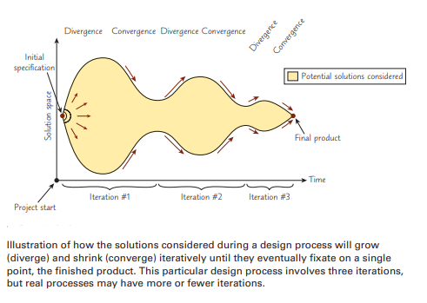

**Shows two concept sketches of personal hovercrafts drawn by two different designers.**

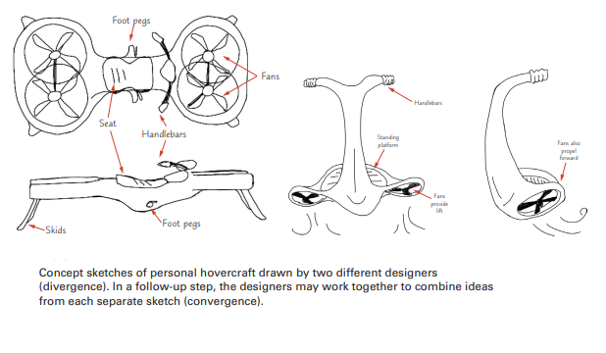

**Surveys, interviews, and focus groups**

* The most straightforward way to elicit requirements and desires from users is simply to ask them. Surveys—online or paper-based—are the simplest and cheapest approach and simply entail distributing a questionnaire to representative users. Online surveys can have significant reach but often yield a low response rate. Furthermore, the feedback received is often superficial in nature.
* In-person interviews are more labor-intensive than surveys but will yield more accurate and high-quality responses. Interviews can take place either in one-on-one settings between designer and user or in focus group discussions with multiple users and designers. Again, the choice between individual or group interviews depends largely on cost; a group session requires less time investment but may not be able to collect in-depth feedback from all participants.
* Depending on the goal of the interview, the designer will take a structured or unstructured approach. Structured interviews are essentially verbal surveys, but the method often lets the designer follow up with additional questions based on the answer. Unstructured interviews have no specific questions to ask the user, only a general discussion topic. Successful designers often combine both strategies in the same session: Some questions are fixed, whereas some are more open-ended. This allows for collecting unsolicited feedback as well as getting answers to specific questions that the designer did not know to ask but that are important to the user.

**Ethnographic observation**

* The early stages of most methodologies include observation of users. Since interface users form a unique culture, ethnographic methods for observing them in the workplace are becoming increasingly important.
* Ethnographers join work or home environments to listen and observe carefully, sometimes stepping forward to ask questions and participate in activities.
* The goal of ethnographic observation for interaction design is to obtain the necessary data to influence interface redesign

Examples of ethnographic observation research include

1. How cultural probes have been adopted and adapted by the HCI community (Boehner et al., 2007),
2. Development of an interactive location-based service for supporting distributed mobile collaboration for home healthcare (Christensen et al., 2007), and
3. Social dynamics influencing technological solutions in developing regions.

**Guidelines for conducting ethnographic studies for interaction design.**

1. Preparation

• Understand policies in the target environment (work, home, public space, etc.).

• Familiarize yourself with the existing interface and its history.

• Set initial goals and prepare questions.

• Gain access and permission to observe or interview.

2.Field study

• Establish a rapport with all users.

• Observe or interview users in their setting, and collect subjective and objective quantitative and qualitative data.

• Follow any leads that emerge from the visits.

• Record your visits.

3.Analysis

• Compile the collected data in numerical, textual, and multimedia databases.

• Quantify data and compile statistics.

• Reduce and interpret the data.

• Refine the goals and the process used.

4. Reporting

• Consider multiple audiences and goals.

• Prepare a report and present the findings.

**Scenario development and storyboarding**

* Scenario development builds on the use case concept and allows for developing specific scenarios when a user engages the interactive system to solve a particular task. Storyboarding is the use of graphical sketches and illustrations to convey important steps in a scenario

This technique can be especially effective when multiple users must cooperate (for example, in control rooms, cockpits, or financial trading rooms) or multiple physical devices are used (for example, at customer-service desks, medical laboratories, or hotel check-in areas).

Scenarios can represent common or emergency situations with both novice and expert users. Personas can also be included in scenario generation. Some scenario writers take a further step and produce videos to convey their intentions.

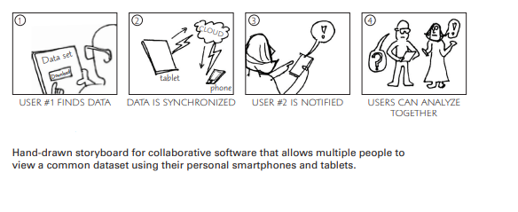

**Prototyping**

* Prototypes, or physical sketches as Buxton (2007) calls them, are particularly powerful design tools because they allow users and designers alike to see and hold (for physical prototypes) representations of the intended interface. They also allow the design team to play out specific scenarios and tests using the prototype. For example, a printed version of the proposed displays can be used for pilot tests, whereas an interactive display with an active keyboard and mouse can be used for more realistic tests

Increasing realism, or fidelity, for a prototype governs the time investment in creating it. Obviously, low-fidelity prototypes are more suitable for early ideation and creativity because they are easily generated and as easily discarded; in fact, the very vagueness of a “quick and dirty” sketch communicates the uncertainty of the ideation process and invites improvements or rejection.

Here are some examples of prototypes at different levels of fidelity:

**• Low-fidelity prototypes** are generally created by sketching, using sticky notes, or cutting and gluing pieces of paper together (paper mockups);

**• Medium-fidelity prototypes** are often called wireframes, provide some standardized elements (such as buttons, menus, and text fields), even if potentially drawn in a sketchy fashion, and have some basic navigation functionality; and

**• High-fidelity prototypes** look almost like the final product and may have some rudimentary computational capabilities; however, the prototype is typically not complete and may not be fully functional.

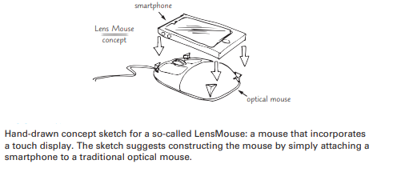

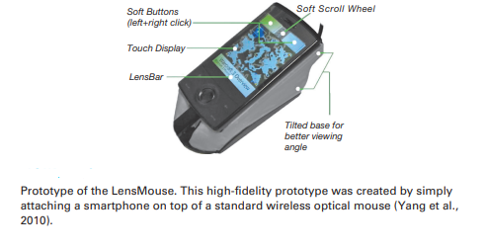

**Design Tools, Practices, and Patterns**

**Design Tools**

* Creating prototypes beyond paper mockups requires using computer programs to prototype a specific interface or app. The simplest approach is to use general purpose drawing and drafting applications for this purpose. For example, prototypes have been developed with simple drawing or word-processing tools or even Microsoft PowerPoint® presentations of screen drawings manipulated with PowerPoint slideshows and other animation. Other design tools that can be used are Adobe InDesign®, Photoshop®, or Illustrator®.
* Dedicated prototyping design tools are specifically designed for the purpose of creating interface mockups rapidly and effortlessly. Since the visual design language varies across different platforms, different tools exist for desktop, mobile, and web. Many design tools use the actual buttons, dropdown menus, and scrollbars used in the interfaces on the specific platform
* Finally, dedicated design tools—so-called graphical user-interface builders— also exist for the final implementation phase when the development team is realizing the planned interface. Many of these builders use a drag-and-drop graphical editor where the interaction designer can construct the final interface by assembling existing interface elements from a library of elements

**Design guidelines and standards**

* Early in the design process, the interaction design team should generate a set of working guidelines. Two people might work for one week to produce a 10-page document, or a dozen people might work for two years to produce a 300-page document. One component of Apple’s success with the original Macintosh was the machine’s early and readable guidelines document, which provided a clear set of principles for the many application developers to follow and thus ensured harmony in design across products. Microsoft’s Windows User Experience Guidelines, which have been refined over the years, also provide a good starting point and an educational experience for many programmers.

Guidelines documents are a powerful tool for interaction design because they

• Provide a social process for developers;

• Record decisions for all parties to see;

• Promote consistency and completeness;

• Facilitate automation of design;

• Allow multiple levels:

* Rigid standards
* Accepted practices
* Flexible guidelines
* Industry-specific guidelines

• Announce policies for:

* Education: How to get it?
* Enforcement: Who reviews?
* Exemption: Who decides?
* Enhancement: How often?

Guidelines creation is often a social process within an organization in order to help gain visibility and build support for the guidelines.

The creation of a guidelines document at the beginning of an implementation project focuses attention on the interface design and provides an opportunity for discussion of controversial issues. When the development team adopts the guidelines, the implementation proceeds quickly and with few design changes.

Suggested content in user experience guidelines documents.

Words, icons, and graphics

• Terminology (objects and actions), abbreviations, and capitalization

• Character set, fonts, font sizes, and styles (bold, italic, underline)

• Icons, buttons, graphics, and line thickness

• Use of color, backgrounds, highlighting, and blinking

Display layout issues

• Menu selection, form fill-in, and dialog-box formats

• Wording of prompts, feedback, and error messages

• Justification, white space, and margins

• Data entry and display formats for items and lists

• Use and contents of headers and footers

• Strategies for adapting to very small and very large displays

Input and output devices

• Keyboard, display, cursor control, and pointing devices

• Sound, voice feedback, speech I/O, touch input, etc.

• Response times for a variety of tasks

• Alternatives for users with disabilities

Action sequences

• Direct-manipulation clicking, dragging, dropping, and gestures

• Command syntax, semantics, and sequences

• Shortcuts and programmed function keys

• Touch input for devices such as smartphones, tablets, and large touch displays

• Error handling and recovery procedures

Training

• Online help, tutorials, and support groups

• Training and reference materials

The “four Es” provide a basis for creating a living document and a lively process:

* Education. Users need training and a chance to discuss the guidelines. Developers must be trained in the resultant guidelines.
* Enforcement. A timely and clear process is necessary to verify that an interface adheres to the guidelines.
* Exemption. When creative ideas or new technologies are used, a rapid process for gaining exemption is needed.
* Enhancement. A predictable process for review, possibly annually, will help keep the guidelines up-to-date.

**Interaction design patterns**

* Design patterns, originally proposed for urban planning (Alexander, 1977) and later software engineering (Freeman et al., 2004), are best-practice solutions to commonly occurring problems specified in such a way that they can be reused and applied to slightly different variations of a problem over and over again. Regardless of discipline, patterns help address a common problem for novice designers: They have very little experience of past work to draw upon when tackling a new problem. In this way, design patterns constitute valuable experience-in-a-can, ready to be used when needed .
* While software engineering design patterns are quite technical in nature, they are particularly useful for the interaction designer with a software engineering bent
* The fact that patterns were originally used to solve problems in urban planning demonstrates that the pattern concept transcends specific disciplines, and the idea has further been applied to areas such as pedagogy, game design, communication policy, visualization, and even chess strategy

here is a list of a few useful interaction design patterns along these lines:

* Model-View-Controller (MVC). A so-called architectural pattern for implementing user interfaces, MVC governs how information should flow between three specific components in the interface: models that represent the state (e.g., a string for an input field or a number for a dial), views that render the state on the display (e.g., the text box or the spinner), and controllers that change the models (e.g., editing the string or increasing/ decreasing the number) as well as the views (e.g., scrolling through a long document).
* Document interface. Many applications, particularly those designed for personal computers, allow opening more than one document at the same time. Document interface patterns capture different ways of managing multiple documents for an application:
* Single document interface (SDI). The simplest document interface pattern,each document opens a new instance of the application. Mobile apps and web applications tend to be built using this pattern.
* Multiple document interface (MDI). Here each document opens an internal window in the main frame, allowing for a single application window even for multiple open documents. Common in personal computer applications.
* Tabbed document interface (TDI). A compromise between SDI and MDI, the tabbed document interface pattern places multiple open documents in tabs in a single instance of the application. Most web browsers use TDI.
* Web application page architecture. Designing a web application is subtly different than designing an application for a personal computer or a mobile device.The page architecture is one of the most important interaction design aspects here:
* Multi-page application (MPA). The traditional way of building a web application is to use multiple pages, one for each specific function in the application. This mimics dialog boxes in desktop applications and is easy to implement by the very nature of HTML and the web, which is organized into separate pages but requires reloading for each page and may thus cause disruption in the user experience.
* Single-page application (SPA). These applications fit on a single webpage,thus mimicking a desktop application, and require no reloading or mode changes, thereby making the user experience fluid and uninterrupted.Instead of page loads, the application state changes dynamically through communication with the web server using modern web technologies such as JavaScript, HTML, and CSS.

**Social Impact Analysis**

* Interactive systems often have a dramatic impact on large numbers of users. To minimize risks, a thoughtful statement of anticipated impacts circulated among stakeholders can be a useful process for eliciting productive suggestions early in the development when changes are easiest. Governments, utilities, and publicly regulated industries increasingly require information systems to provide services. A social impact statement, similar to an environmental impact statement, might help to promote high-quality systems in government-related applications

An outline for a social impact statement might include these sections (Shneiderman and Rose, 1996):

---Describe the new system and its benefits.

* Convey the high-level goals of the new system.
* Identify the stakeholders.
* Identify specific benefits.

---Address concerns and potential barriers.

* Anticipate changes in job functions and potential layoffs.
* Address security and privacy issues.
* Discuss accountability and responsibility for system misuse and failure.
* Avoid potential biases.
* Weigh individual rights versus societal benefits.
* Assess tradeoffs between centralization and decentralization.
* Preserve democratic principles.
* Ensure diverse access.
* Promote simplicity and preserve what works.

---- Outline the development process.

* Present an estimated project schedule.
* Propose a process for making decisions.
* Discuss expectations of how stakeholders will be involved.
* Recognize needs for more staff, training, and hardware.
* Propose a plan for backups of data and equipment.
* Outline a plan for migrating to the new system.
* Describe a plan for measuring the success of the new system

**Legal Issues**

As user interfaces have become more prominent in society, serious legal issues have emerged. Every developer of software and information should review legal issues that may affect design, implementation, deployment, marketing, and use. For more information, Baase (2013) gives an in-depth overview of such social, legal, philosophical, ethical, political, constitutional, and economic implications of computing.

* **Privacy and security** are always a concern whenever computers are used to store data or to monitor activity. Medical, legal, financial, and other data often have to be protected to prevent unapproved access, illegal tampering, inadvertent loss, or malicious mischief.
* A second concern encompasses **safety and reliability.** User interfaces for aircraft, automobiles, medical equipment, military systems, utility control rooms, and the like can affect life-or-death decisions. If air traffic controllers are confused by the situation display, they can make fatal errors. If the user interface for such a system is demonstrated to be difficult to understand, it could leave the designer, developer, and operator open to a lawsuit alleging improper design
* A third issue is **copyright or patent protection for software** (Lessig, 2006; Samuelson and Schultz, 2007; McJohn, 2015). Software developers who have spent time and money developing a package are understandably frustrated when potential users make illegal copies of the package rather than buying it. Technical schemes have been tried to prevent copying, but clever hackers can usually circumvent the barriers. It is unusual for a company to sue an individual for copying a program, but cases have been brought against corporations and universities
* A fourth concern is with **copyright protection for online information, images, or music**. If customers access an online resource, do they have the right to store the information electronically for later use? Can the customer send an electronic copy to a colleague or friend? Who owns the “friends” list and other shared data in social networking sites? Do individuals, their employers, or network operators own the information contained in e-mail messages? The expansion of the web, with its vast digital libraries, has raised the temperature and pace of copyright discussions
* A fifth issue is freedom of **speech in electronic environments**. Do users have a right to make controversial or potentially offensive statements through e-mail or social media? Are such statements protected by freedom of speech laws, such as the U.S. First Amendment? Are networks similar to street corners, where freedom of speech is guaranteed, or are networks similar to television broadcasting, where community standards must be protected? Should network operators be responsible for or prohibited from eliminating offensive or obscene jokes, stories, or images? Controversy has raged over whether Internet service providers have a right to prohibit e-mail messages that are used to organize consumer rebellions against themselves
* Other legal concerns include adherence to laws requiring equal access for users with disabilities and attention to changing laws in countries around the world. Do Yahoo! and eBay have to enforce the laws of every country in which they have customers? These and other issues mean that developers of online services must be sure to consider all the legal implications of their design decisions

**Direct manipulation Introduction**

Certain interactive systems generate a glowing enthusiasm among users that is in marked contrast with the more common reaction of reluctant acceptance or troubled confusion. The enthusiastic users report the following positive feelings:

• Mastery of the interface

• Competence in performing tasks

• Ease in learning originally and in assimilating advanced features

• Confidence in the capacity to retain mastery over time

• Enjoyment in using the interface

• Eagerness to show off the interface to novices

• Desire to explore more powerful aspects

These feelings convey an image of a truly pleased user. The central ideas in such satisfying interfaces, now widely referred to as direct-manipulation interfaces(Shneiderman, 1983), are visibility of the objects and actions of interest; rapid,reversible, incremental actions; and replacement of typed commands by a pointing action on the object of interest. Direct-manipulation ideas are at the heart of many contemporary and advanced non-desktop interfaces. Game designerscontinue to lead the way in creating visually compelling 3-D scenes with characters (sometimes designed and user-created) controlled by novel pointing devices. At the same time, interest in remote-operated (teleoperated) devices has blossomed, enabling operators to look through distant microscopes or fly drones.

Direct manipulation

* Direct manipulation as a concept has been around since before computers. The metaphor of direct manipulation works well in computing environments and was introduced in the early days of Xerox PARC and then widely disseminated by Shneiderman (1983). Direct-manipulation designs can provide the capability for differing populations and easily stretch across international boundaries
* favorite example of direct manipulation is driving an automobile. The scene is directly visible through the front window, and performance of actions such as braking and steering has become common knowledge in our culture. To turn left, for example, the driver simply rotates the steering wheel to the left. The response is immediate and the scene changes, providing feedback to refine the turn. Now imagine how difficult it would be trying to accurately turn a car by typing a command or selecting “turn left 30 degrees” from a menu. The graceful interaction in many applications is due to the increasingly elegant application of direct manipulation.
* Driverless cars may soon respond to commands like “take me to Baltimore airport,” but they are a long way from matching the skills of drivers at the wheel while navigating snow-covered roads or police hand signals at accident sites
* Before designing for current devices, it makes sense to reflect where early design has been. In the early days of office automation, there was no such thing as a direct-manipulation word processor or a presentation system like PowerPoint. Word processors were command-line–driven programs where the user typically saw a single line at a time. Keyboard commands were used along with inserting special commands to provide instructions for viewing and printing the documents often as a separate operation. Similarly, with presentation programs, specialized commands were used to set the font style, color, and size. Obviously, these were very limited compared to the numerous font families available today. Most users today are used to a WYSIWYG (What You See Is What You Get) environment enhanced by direct-manipulation widgets.

The three principles and attributes of direct manipulation

* The attraction of direct manipulation is apparent in the enthusiasm of the users. Each example has problematic features, but they demonstrate the potent advantages of direct manipulation, which can be summarized by three principles:

1. **Continuous representations** of the objects and actions of interest with meaningful visual metaphors
2. **Physical actions** or presses of labeled interface objects (i.e., buttons) instead of complex
3. **Rapid, incremental, reversible actions** whose effects on the objects of interest are visible immediately

Simple metaphors or analogies with a minimal set of concepts—for example, pencils and paintbrushes in a drawing tool—are a good starting point. Mixing metaphors from two sources may add complexity that contributes to confusion. Also, the emotional tone of the metaphor should be inviting rather than distasteful or inappropriate. Since the users are not guaranteed to share the designer’s understanding of the metaphor, analogy, or conceptual model used, ample testing is required.

* Using these three principles, it is possible to design systems that have these beneficial attributes:
* Novices can learn basic functionality quickly, usually through a demonstration by a more experienced user.
* Experts can work rapidly to carry out a wide range of tasks, even defining new functions and features. Knowledgeable intermittent users can retain operational concepts.
* Error messages are rarely needed.
* Users can immediately see whether their actions are furthering their goals, and if the actions are counterproductive, they can simply change the direction of their activity.
* Users experience less anxiety because the interface is comprehensible and because actions can be reversed easily.
* Users gain a sense of confidence and mastery because they are the initiators of action, they feel in control, and they can predict the interface’s responses.

Translational distances with direct manipulation

* The effectiveness and reality of the direct-manipulation interface are based on the validity and strength of the metaphor chosen to represent the actions and objects. Using familiar metaphors creates easier learning conditions for users and lessens the number of mistakes and incorrect actions. Adequate testing is needed to validate the metaphor. Special attention needs to be paid to the user characteristics such as age, reading level, educational background, prior experiences, and any physical disabilities.
* One way of trying to understand and categorize the direct-manipulation metaphor is by looking at the translational distance between users and the representation of the metaphor, which will be referred to as strength.

Examples of translational distances (strength).

* Weak—early video game controllers
* Medium—touch screens, multi-touch
* Strong—data glove, gesturing, manipulating tangible objects
* Immersive—virtual reality, i.e, oculus rift

**Weak direct manipulation** is what can be described as basic direct manipulation. There is a mouse, trackpad, joystick, or similar device translating the user’s physical action into action in the virtual space using some mapping function.

M**edium direct manipulation** is the next step moving along the continuum. The translational distance is reduced. Instead of communicating with the virtual space with the device, the user reaches out and touches, moves, and grabs the entities in the on-screen representation. Examples of this include touchscreens (mobile, kiosk, and desktop).

**strong direct manipulation** involves actions such as gesture recognition with various body parts. It may be the user’s hand, foot, head, or full body (whatever controls the action) that is “virtually” placed inside the physical space .

**Disadvantages of  Direct manipulation**

Direct manipulation is a user interface concept in human-computer interaction (HCI) where users interact with objects and actions directly, rather than through abstract commands or intermediaries. While direct manipulation has several advantages, it also comes with some disadvantages:

1. Complexity for Novice Users: Direct manipulation can be more intuitive for experienced users who are familiar with the underlying concepts. However, for novice users, the direct manipulation of objects might be overwhelming and confusing, as it requires an understanding of how the system's objects and interactions work.
2. Limited to Graphical Interfaces: Direct manipulation heavily relies on graphical interfaces and physical interactions like dragging, dropping, and resizing. This can limit its applicability in non-graphical environments or for users who have physical limitations that prevent them from using certain gestures.
3. Inefficient for Precise Tasks: For tasks that require high precision or dealing with large sets of data, direct manipulation might become inefficient. Traditional text-based or command-based approaches can often be more accurate and quicker for these types of tasks.
4. Lack of Customization: In some cases, direct manipulation interfaces might not allow users to customize interactions or create complex workflows. This can limit power users who want to tailor their interactions according to their specific needs.
5. Limited Screen Space: As screen sizes vary across devices, direct manipulation interfaces might not scale well on smaller screens or devices with limited visual real estate. This can lead to cluttered interfaces and decreased usability.
6. Cognitive Load for Complex Actions: While direct manipulation is great for simple tasks, it can become mentally taxing for more complex actions that involve multiple steps or intricate interactions. Users might struggle to remember the sequence of actions or the correct gestures required.
7. Discoverability Issues: Some features or interactions in a direct manipulation interface might not be immediately discoverable, leading to hidden functionality that users might miss. This can be particularly challenging for new users who are not familiar with all the available gestures and interactions.
8. Limited Accessibility: Direct manipulation interfaces might not be accessible to users with disabilities, particularly those who have difficulty with fine motor skills or certain gestures. Designing inclusive interfaces that cater to a diverse range of users can be challenging.
9. Dependency on Hardware: Direct manipulation interfaces often rely on specific hardware capabilities such as touch screens or motion sensors. This can limit the availability of the interface to devices that support these technologies.
10. Complexity for Advanced Interactions: While direct manipulation is well-suited for simple interactions, it might struggle to support more advanced or complex interactions that involve intricate data manipulation or abstract operations.

**The continuing evolution of direct manipulation**

A successful direct-manipulation interface must present an appropriate representation or model of reality. With some applications, the jump to visual language may be difficult, but after using visual direct-manipulation interfaces, most users and designers can hardly imagine why anyone would want to use a complex syntactic notation to describe an essentially visual process. It is hard to conceive of learning the commands for the vast number of features in modern word processors, drawing programs, or spreadsheets, but the visual cues, icons, menus, and dialog boxes make it possible for even intermittent users to succeed.

Advantages and disadvantages of direct manipulation.

Direct Manipulation Advantages

1. Visually presents task concept
2. Allows easy learning
3. Allows easy retention
4. Allows errors to be avoided
5. Encourages exploration
6. Affords high subjective satisfaction

Disadvantages

1. May be hard to program
2. Accessibility requires special attention

Users are trying to better understand all the data and other visual content that are now available. One way to manage this information is through the use of a dashboard (Few, 2013). Being able to see a large volume of information (big data) at one time and to directly manipulate it and observe the impact visually is a powerful concept.

Weiser’s (1991) influential vision of ubiquitous computing described a world where computational devices were everywhere—in your hands, on your body, in your car, built into your home, and pervasively distributed in your environment. The 1993 special issue of Communications of the ACM (Wellner et al., 1993) showed provocative prototypes that refined Weiser’s vision. It offered multiple visions of beyond-the-desktop designs that used freehand gestures and small mobile devices whose displays changed depending on where users stood and how they pointed the devices. Almost 25 years later, Weiser’s full vision has not yet been realized, but the social-media aspect of ubiquitous computing has blossomed.

**Some Examples of Direct Manipulation**

* Geographical systems including GPS (global positioning systems)
* Video games
* Computer-aided design and fabrication
* Direct-manipulation programming and configuration

**Geographical systems including GPS (global positioning systems)**

* For centuries, travelers have relied on maps and globes to better understand the Earth and geographical systems. As graphic- and image-capture capabilities increased (both real-world and human-generated), it was a natural progression to create systems to represent both a current location—”where we are”—and a target location—”where we want to go.” Of course, as prices dropped, these types of systems became available as commercial GPS systems for cars, for walking, and even for the mobile phone. Being able to directly see the alternatives on the devices as well as how to move from the current location to the target location including manipulating the routes is another application of direct manipulation.
* Google Maps™, MapQuest, Google Street View, Garmin, National Geographic, and Google Earth™ combine geographic information from aerial photographs, satellite imagery, and other sources to create a vast database of graphical information that can easily be viewed and displayed.

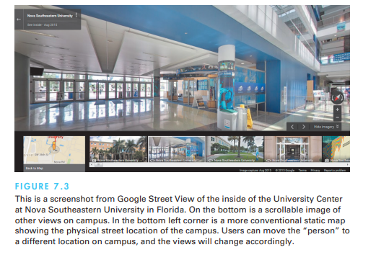

**Video games**

* For many people, the most exciting, well-engineered, and commercially successful application of the direct-manipulation concepts lies in the world of video games. The early but simple and popular game Pong® (created in 1972) required the user to rotate a knob that moved a white rectangle on the screen. A white spot acted as a ping-pong ball that ricocheted off the wall and had to be hit back by the movable white rectangle. Users developed speed and accuracy in placing the “paddle” to keep the increasingly speedy ball from getting past, while the computer speaker emitted a ponging sound when the ball bounced.
* Some cataloguers state that we are in the eighth generation of video games. Parkin (2014) provides an illustrated history of five decades of video games. Last generation’s Nintendo Wii, Sony PlayStation 3, and Microsoft Xbox 360™ have given way to this generation’s Nintendo Wii U, Sony PlayStation 4, and Microsoft Xbox One in a very short time, and continued advances are expected. These gaming platforms have brought powerful 3-D graphics hardware to the home and have created a remarkable international market. Gaming experiences are being enhanced by combining 3-D user-interface technologies, such as stereoscopic 3-D, head tracking, and finger-count gestures

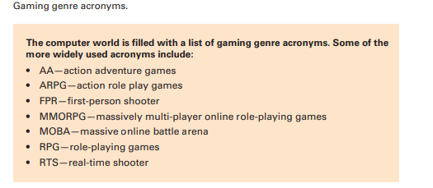

* Some web-based game environments may involve millions of users and thousands of user-constructed “worlds,” such as schools, shopping malls, or urban neighborhoods. Game devotees may spend dozens of hours per week immersed in their virtual worlds, chatting with collaborators or negotiating with opponents. World of Warcraft (developed and published by Blizzard Entertainment) has been the mainstay and most popular of the MMORPG games with more than 5.6 million subscribers as of 2015

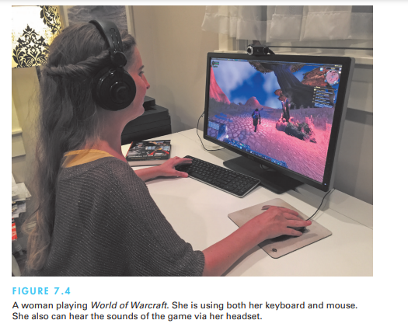

* Most games continuously display a numeric score so that users can measure their progress and compete with their previous performance, with friends, or with the highest scorers. Typically, the 10 highest scorers get to store their initials in the game for public display. This strategy provides one form of positive reinforcement that encourages mastery. Studies with elementary-school children have shown that continuous display of scores is extremely valuable. Machine-generated feedback—such as “Very good” or “You’re doing great!

**Computer-aided design and fabrication**

* Most computer-aided design (CAD) systems for automobiles, electronic circuitry, aircraft, or mechanical engineering use principles of direct manipulation. Building and home architects now have at their disposal powerful tools, provided by companies such as Autodesk, that provide components to handle structural engineering, floor plans, interiors, landscaping, plumbing, electrical installation, and much more. With such applications, the designer may see a circuit schematic on the screen and, with mouse clicks, be able to move components into or out of the proposed circuit.
* There are large manufacturing companies using AutoCAD® and similar systems, but there are also other specialized design programs for kitchen and bathroom layouts, landscaping plans, and other homeowner-type situations. These programs allow users to control the angle of the sun during the various seasons to see the impact of the landscaping and shadows on various portions of the house. They allow users to view a kitchen layout and calculate square footage estimates for floors and countertops and even print out materials lists directly from the software.

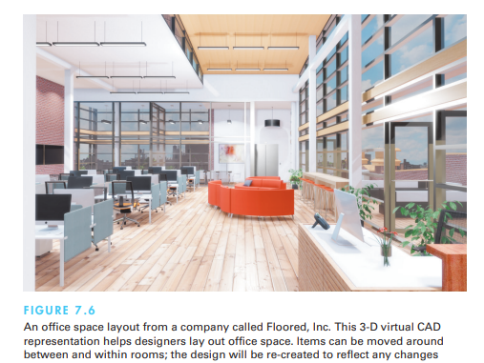

* Another emerging use of direct manipulation involves home automation. Since so much of home control involves floor plans, direct-manipulation actions naturally take place on a display of the floor plan with selectable icons for each status indicator (such as a burglar alarm, heat sensor, or smoke detector) and for each activator (such as controls for opening and closing curtains or shades, for air conditioning and heating, or for audio and video speakers or screens). For example, users can route a recorded TV program being watched in the living room to the bedroom and kitchen by merely dragging the on-screen icon into those rooms, and they can adjust the volume by moving a marker on a linear scale. The action is usually immediate and visible and can be easily reversed as well

**Direct-manipulation programming and configuration**

* Performing tasks by direct manipulation is not the only goal. It should be possible to do programming by direct manipulation as well, at least for certain problems. How about moving a drill press or a surgical tool through a complex series of motions that are then repeated exactly? Automobile seating positions and mirror settings can be set as a group of preferences for a particular driver and then adjusted as the driver settles in place. Likewise, some professional television-camera supports allow the operator to program a sequence of pans or zooms and then to replay it smoothly when required.
* Programming of physical devices by direct manipulation seems quite natural, and an adequate visual representation of information may make direct manipulation programming possible in other domains. Spreadsheet packages such as Excel™ have rich programming languages and allow users to create portions of programs by carrying out standard spreadsheet actions. The result of the actions is stored in another part of the spreadsheet and can be edited, printed, and stored in a textual form. Database programs such as Access™ allow users to create buttons that when activated will set off a series of actions and commands and even generate a report. Similarly, Adobe Photoshop records a history of user actions and then allows users to create programs with action sequences and repetition using direct manipulation

**2-D and 3-D Interfaces**

* some designers dream about building interfaces that approach the richness of 3-D reality. They believe that the closer the interfaces are to the real world, the easier usage will be. This extreme interpretation of direct manipulation is a dubious proposition, since user studies show that disorienting navigation, complex user actions, and annoying occlusions can slow performance in the real world as well as in 3-D interfaces (Cockburn and McKenzie, 2002). Many interfaces (sometimes called 2-D interfaces) are designed to be simpler than the real world by constraining movement, limiting interface actions, and ensuring visibility of interface objects
* seek merely to mimic reality. For some computer-based tasks—such as medical imagery ,architectural drawing, computer-assisted design, chemical-structure modeling ,and ­scientific simulations—pure 3-D representations are clearly helpful and have become major industries. However, even in these cases, the ­successes are  often due to design features that make the interface better than reality.

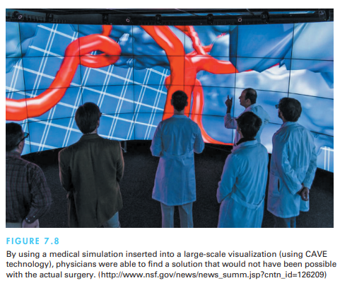

enumeration of features for effective 3-D interfaces might serve as a checklist for designers, researchers, and educators:

* Use occlusion, shadows, perspective, and other 3-D techniques carefully.
* Minimize the number of navigation steps required for users to accomplish their tasks.
* Keep text readable (better rendering, good contrast with background, and no more than 30-degree tilt).
* Avoid unnecessary visual clutter, distraction, contrast shifts, and reflections.
* Simplify user movement (keep movements planar, avoid surprises like going through walls).
* Prevent errors (that is, create surgical tools that cut only where needed and chemistry kits that produce only realistic molecules and safe compounds).
* Simplify object movement (facilitate docking, follow predictable paths, limit rotation).
* Organize groups of items in aligned structures to allow rapid visual search.
* Enable users to construct visual groups to support spatial recall (placing items in corners or tinted areas)

Breakthroughs based on clever ideas seem possible. Enriching interfaces with stereo displays, haptic feedback, and 3-D sound may yet prove beneficial in more than specialized applications. Bigger payoffs are more likely to come sooner if these guidelines for inclusion of enhanced 3-D features are followed:

* Provide overviews so users can see the big picture (plan view display, aggregated views).
* Allow teleportation (rapid context shifts by selecting destination in an overview).
* Offer x-ray vision so users can see into or beyond objects.
* Provide history keeping (recording, undoing, replaying, editing).
* Permit rich user actions on objects (save, copy, annotate, share, send).
* Enable remote collaboration (synchronous, asynchronous).
* Give users control over explanatory text (pop-up, floating, or excentric labels and screen tips) and let them view details on demand.
* Offer tools to select, mark, and measure.
* Implement dynamic queries to rapidly filter out unneeded items.
* Support semantic zooming and movement (simple action brings object front and center and reveals more details)
* Enable landmarks to show themselves even at a distance.
* Allow multiple coordinated views (users can be in more than one place at a time and see data in more than one arrangement at a time).
* Develop novel 3-D icons to represent concepts that are more recognizable and memorable.

**Teleoperation and Presence**

* Teleoperation has two parents: direct manipulation in personal computers and process control, where human operators control physical processes in complex environments. Typical tasks are operating power or chemical plants, controlling manufacturing, surgery, flying airplanes or drones, or steering vehicles. If the physical processes take place in a remote location, we talk about teleoperation or remote control. To perform the control task remotely, the human operator may interact with a computer, which may carry out some of the control tasks without any interference by the human operator.
* There are great opportunities for the remote control or tele operation of devices if acceptable user interfaces can be constructed. When designers can provide adequate feedback in sufficient time to permit effective decision making, attractive applications in manufacturing, medicine, military operations, and computer-supported collaborative work are viable. Home-automation applications extend remote operation of various devices to security and access systems, energy control, and operation of appliances. Scientific applications in space, underwater, or in hostile environments enable new research projects to be conducted economically and safely. The recent introduction of affordable drones will be yet another facet of tele operation.
* A typical remote application is telemedicine, or medical care delivered over communication links (Sonnenwald et al., 2014). Telemedicine can be used more broadly to allow physicians to examine patients remotely and surgeons to carry out operations across continents. Telehealth is being widely used in the Veteran’s Administration Veterans can come into the local VA office where technology visits with the various medical personnel can be conducted via Telehealth.

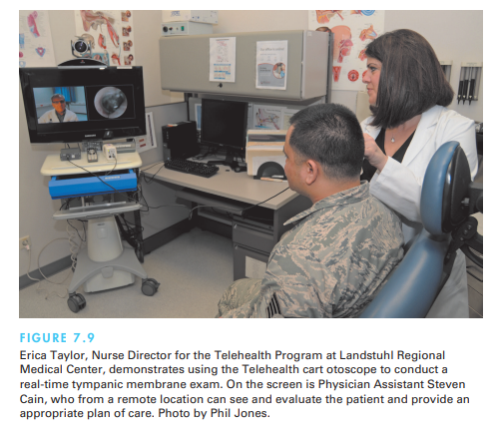

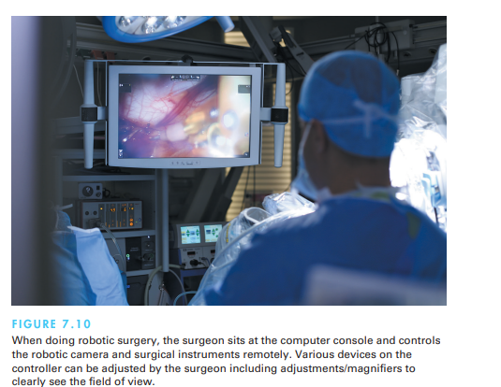

The architecture of remote environments introduces several complicating factors:

1. **Time delays.** The network hardware and software cause delays in sending user actions and receiving feedback: a transmission delay, or the time it takes for the command to reach the microscope (in our example, transmitting the command over the network), and an operation delay, or the time until the microscope responds. These delays in the system prevent the operator from knowing the current status of the system.
2. **Incomplete feedback.** Devices originally designed for direct control may not have adequate sensors or status indicators. For instance, the microscope can transmit its current position, but it operates so slowly that it does not indicate the exact current position.
3. **Unanticipated interferences:** Since the operated devices are remote, unanticipated interferences are more likely to occur than with physically present direct-manipulation environments

* One solution to these problems is to make explicit the network delays and breakdowns as part of the system. The user sees a model of the starting state of the system, the action that has been initiated, and the current state of the system as it carries out the action. It may be preferable for users to specify a destination (rather than a motion) and wait until the action is completed before readjusting the destination if necessary. Avenues for continuous feedback also are important.
* Teleoperation is also commonly used by the military and by civilian space projects. Military applications for unmanned aircraft gained visibility during the recent wars in Afghanistan and Iraq. Reconnaissance drones and teleoperated missile-firing aircraft were widely used. Agile and flexible mobile robots exist for many hazardous duty situations (Murphy, 2014). Military missions and harsh environments, such as undersea and space exploration, are strong drivers for improved designs.

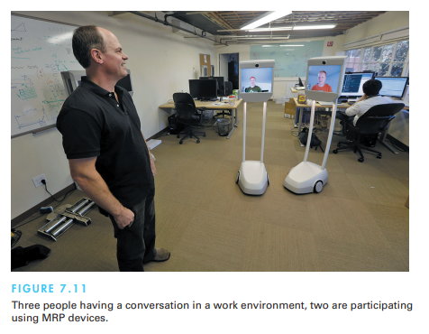

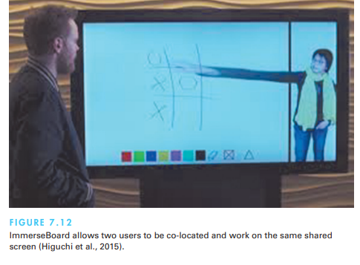

**Augmented and Virtual Reality**

* Flight-simulator designers work hard to create the most realistic experience for fighter and airline pilots. The cockpit displays and controls are taken from the same production line that creates the real ones. Then the windows are replaced by high-resolution computer displays, and sounds are choreographed to give the impression of engine start or reverse thrust. Finally, the vibration and tilting during climbing or turning are created by hydraulic jacks and intricate suspension systems. This elaborate technology may cost $100 million, but even so, it is a lot cheaper, safer, and more useful for training than the $400-million jet that it simulates.
* Flying a plane is a complicated and specialized skill, but simulators are available for more common—and some surprising—tasks under the alluring name of virtual reality or the more descriptive virtual environments.

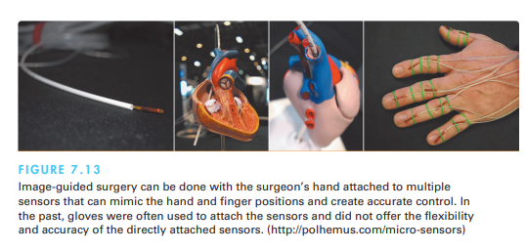 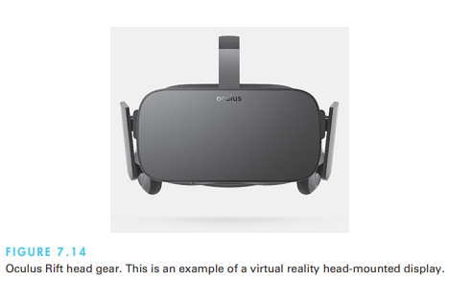 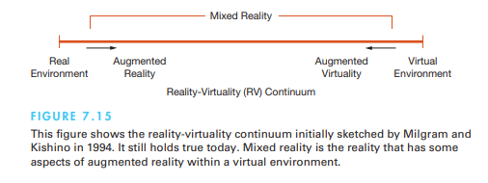

**Augmented reality**

* Augmented reality enables users to see the real world with an overlay of additional information; for example, while users are looking at the walls of a building, their semitransparent eyeglasses may show the location of electrical wires and studwork. Medical applications, such as allowing surgeons or their assistants to look at patient while they see an overlay of a sonogram or other pertinent information to help locate a tumor, also seem compelling

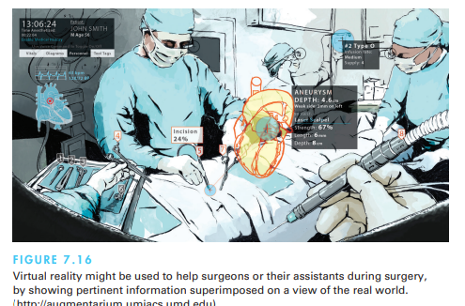

* An interior designer walking through a house with a client should be able to pick up a window-stretching tool or pull on a handle to try out a larger window or to use a room-painting tool to change the wall colors while leaving the windows and furniture untouched. Companies like IKEA are providing augmented reality tools so customers can visualize the products via their catalog in their own homes and rooms

**Advantages:**

* Enhanced User Experience: AR can provide users with a more engaging and interactive experience by adding virtual elements to their real-world surroundings. This can make tasks more visually appealing and enjoyable.
* Contextual Information: AR can offer users relevant contextual information in real-time. For example, AR apps can display information about landmarks or objects as users point their device's camera at them.
* Spatial Interaction: AR enables spatial interactions where users can manipulate virtual objects using gestures, touch, or even voice commands. This creates a more intuitive and natural interaction paradigm.
* Training and Education: AR can be used for training purposes, allowing users to learn and practice tasks in a simulated environment before applying them in the real world. This is particularly useful in fields like medicine, engineering, and aviation.
* Visualization: AR can help users visualize complex data or concepts by presenting them in 3D models or interactive visualizations directly overlaid onto the physical world.
* Remote Assistance: AR can facilitate remote collaboration by allowing experts to provide guidance and instructions to users in real-time using annotations and virtual overlays.

**Challenges:**

* Hardware Limitations: Effective AR experiences often require specialized hardware such as cameras, sensors, and displays. Not all devices may have these capabilities, limiting the accessibility of AR applications.
* User Interface Design: Designing intuitive and user-friendly AR interfaces can be challenging. Balancing the integration of virtual elements with real-world context while maintaining usability requires careful consideration.
* Physical and Cognitive Load: AR experiences can place additional cognitive and physical load on users. Interacting with virtual elements while being aware of the physical environment requires multitasking and can be tiring.
* Privacy Concerns: AR apps might involve capturing and processing real-world images and data. This can raise privacy concerns related to data collection, storage, and potential misuse.
* Ethical Considerations: AR can blur the boundaries between the digital and physical worlds, potentially leading to ethical dilemmas, like issues related to misinformation, public safety, and invasive advertising.
* Content Creation and Quality: Developing high-quality AR content, such as realistic 3D models or accurate spatial tracking, can be resource-intensive and technically challenging.
* Social Acceptance: As AR becomes more prevalent, societal norms and expectations about public behavior and interaction might need to be redefined.

**Virtual reality**

* The presence aspect of virtual reality breaks the physical limitations of space and allows users to act as though they are somewhere else. Practical thinkers immediately grasp the connection to remote direct manipulation, remote control, and remote vision, but the fantasists see the potential to escap reality and to visit science-fiction worlds, cartoonlands, previous times in history, galaxies with different laws of physics, or unexplored emotional territories e current

**Advantages:**

* Immersive Experience: VR provides a highly immersive experience by placing users within a completely virtual environment. This immersive quality can lead to heightened engagement and a sense of presence.
* Experiential Learning: VR can facilitate experiential learning by allowing users to simulate real-world scenarios and interactions. This is particularly valuable in fields like training, education, and simulation.
* Spatial Interaction: VR enables users to interact with virtual objects in 3D space using natural gestures and movements, creating a more intuitive and engaging interaction paradigm.
* Design and Visualization: VR is useful for visualizing and experiencing designs, architecture, and prototypes before they are physically created. This can aid in design reviews and iterative development.
* Therapeutic and Rehabilitation Applications: VR has been used in healthcare for pain management, exposure therapy, and physical rehabilitation, leveraging the immersive environment to engage and motivate patients.
* Collaboration and Communication: VR can facilitate remote collaboration by creating shared virtual spaces where users from different locations can interact as if they were in the same physical room.

**Challenges:**

* Hardware and Accessibility: VR experiences require specialized hardware, including headsets, controllers, and often powerful computers. This can limit accessibility and adoption due to cost and technical requirements.
* Motion Sickness and Discomfort: Some users may experience motion sickness, discomfort, or visual fatigue when using VR systems due to factors like latency, mismatch between visual and vestibular cues, and limited field of view.
* Content Quality: Developing high-quality VR content, including realistic environments, textures, and interactions, can be resource-intensive and technically demanding.
* Isolation and Social Disconnect: While VR can create immersive experiences, it can also lead to isolation and social disconnect if users are fully immersed in virtual worlds for extended periods.
* Health and Safety Concerns: Prolonged use of VR headsets may have health implications, such as eyestrain, discomfort, and posture-related issues.
* Limited Physical Interactions: While VR enables spatial interaction, it may lack the tactile feedback and physical interactions that users have in the real world.
* Ethical Considerations: As with any emerging technology, VR raises ethical questions related to privacy, data security, content moderation, and the potential for addiction.
* Learning Curve: New users might find the controls and interactions in VR environments initially challenging, requiring time to adapt and become proficient.

